UniVerse (One Platform, Endless Connection)
Final Year Project Proposal
BSCS
By
S# | Name | Registration #/Roll #/Section | Mobile # | E-Mail
1. | M. Zohaib Sajid | Fa-22-BSCS-369 | +92 333 5100150 | zohaibsajid369@gmail.com
2. | M. Abdullah bin Babar | Fa-22-BSCS-306 | +92 331 8550446 | abdullahbinbabar786@gmail.com

Supervised by:
Ayza Batool ___________________ (Signature)



Department of Computer Science
Lahore Garrison University
Lahore
Table of Contents
1. Abstract 3
2. Introduction 3
2.1 Revenue and Market Potential 4
2.2 Technology Overview 5
3. Problem Statement 6
3.1 Why It Matters 6
3.2 Who Needs the Solution 6
3.3 Main Points 7
3.4 What Exactly Needs to Be Solved 7
4. Related Work 8
5. Project Scope 8
6. Project Development Methodology 9
7. Project Milestones and Deliverables 10
8. References 10

1. Abstract
Most students in universities have a problem in keeping up with activities, societies, and different types of clubs within the university. The data is usually distributed among various informal channels like board of bullets, WhatsApp and social media. Such system of fragmented communication results into minimal engagement, lost opportunities, and inability to find events or become a part of a society that interests a student. Subsequently, the lack of a centralized communication medium hinders participation, lessens awareness and damages the overall attitude of community in the university setting.
The solution that has been offered is known as UniVerse, which is a Progressive Web Application (PWA) that utilizes the Artificial Intelligence (AI) and integrates all the information related to the society and club in one accessible platform. It offers current information on future and past events, provides the option to explore and participate in societies and enables the societies to effectively management the members and events. Instructed by embedded discussion rooms and chatbot powered by the AI, students have an opportunity to get immediate responses to their questions, which creates an even more interconnected and interactive online space that enhances communication between students and organizers of society.
UniVerse is both front-end and back-end developers based on React.js and Node.js respectively to make the user-friendly and interactive interface and provide the rest server and API management. MongoDB atlas is the primary database used to manage user, society, and the events data. Firebase Cloud Messaging and WebSocket are used to implement real-time notifications and the chat functionality. Also, the AI layer uses Natural Language Processing (NLP) or API-based services to deliver intelligence, context-aware response to ensure efficient, engaging and user-friendly experience on all devices.

2. Introduction
Higher learning institutions offer many ways through which students can enhance necessary academic, interpersonal and leadership skills by being involved in the university societies, university clubs and co-curricular communities. Such platforms not only support co-working and personal advancement, but also help students develop academically and professionally in a great way. Nonetheless, learning about these societies, students tend to have difficulties with accessing the information about these societies that are relevant and timely. The information provided is often distributed across numerous untrustworthy or inconsistently updated informal sources like the bulletin boards, as well as on the social media pages and groups that are typically not verified. This fragmentation brings about a barrier in communication, declines awareness, and prevents active engagement. Earlier studies have emphasized the inefficiency and lack of communication of manualized and decentralized systems in managing clubs, which impedes the participation of students and organizational performance (Chavhan et al., 2025).
UniVerse has been developed to deal with these problems, as an academic-centered AI-driven Progressive Web Application (PWA), providing a unified and standardized digital experience to university societies and clubs. The system has allowable features that make it easy to find societies and become members, communicate updates, news and multimedia files and engage in reflective online discussions. UniVerse will increase access and transparency and efficiency by merging all data and communications of interests of the society into a centralized platform. In addition, the platform promotes a culture of interaction and sharing of knowledge, and allows students to be always informed as well as participate in academic and co-curricular activities. The initiative further helps in making communication between the students and societies more simple, as well as making the university community more connected, informed and skill-based.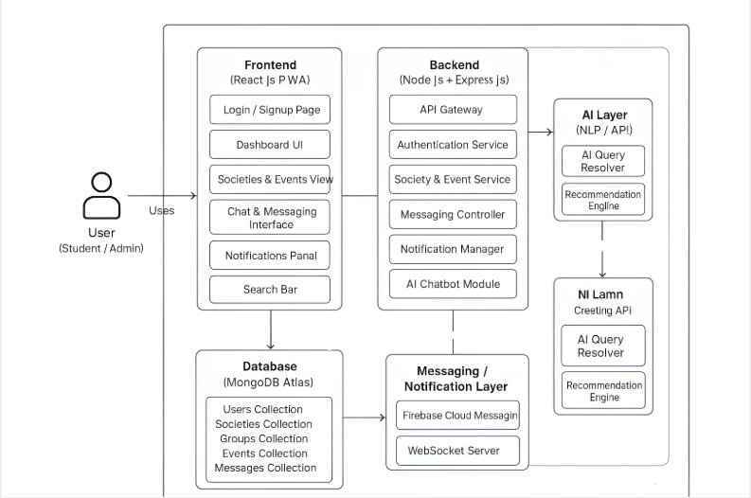
Figure 2.1 Architecture Diagram of PWA UniVerse

2.1 Revenue and Market Potential

Despite the fact that the main goal of UniVerse is to improve the engagement of students and simplify the process of communication inside academic societies, the service has a great commercializing and institutionalization potential. UniVerse is centralized and efficient system of controlling society; therefore, universities should implement it as an official digital tool of their student organizations, events, and memberships control. The design is in harmony with the increasing needs of digital governance tools within institutions of higher learning that want to modernize the student affairs management aspect, and enhance the efficiency of the administration aspect.

Through the business aspect, UniVerse presents several revenue generating avenues besides its academic role. Prospective streams would be collaborations with social networks on the promotional outreach, partnership and sponsors of brands aimed at engaging with student communities, event-based advertising, and the incorporation of analytical software to enable an institution to monitor engagement levels and measures of participation. Gunedski (2025) also said that the student organization management software market is growing in the world due to the necessity to have an efficient digital infrastructure in universities. Consequently, UniVerse does not only gather academic and social interaction but, to a greater extent, it is a marketable, scalable and sustainable digital solution in the field of higher education.

2.2 Technology Overview
UniVerse will be made in the format of Progressive Web Application (PWA) to be accessible, responsive, and cross-platform. The application will be developed based on React.js as the frontend and offer an interactive and dynamic user interface that will work on desktops and handheld devices. The backend will be done in the form of Node.js running on the Express.js environment to allow quick and scalable operations on the server side. To manage the database, MongoDB Atlas will be used because it has flexibility, and the ability to accept a significant amount of unstructured data easily to facilitate the opportunity to easily exchange data between the frontend and the backend.
Artificial Intelligence (AI) will also be incorporated into the system to improve interaction with users and provide the use of such features as smart search and automated query responses. The AI module can be implemented with Natural language processing (NLP), API-based models to produce intelligent context-based responses to user questions depending on how it is implemented. WebSocket connections or Firebase Cloud Messaging (FCM) will be used to support real-time messaging and notifications and maintain the timely information flow and effective interaction between users. The use of these technologies will see UniVerse provide a stable, smart, and interactive virtual space that links the students, societies, and administrators together.

3. Problem Statement
Students often experience difficulty in keeping up with campus life because of ineffective communication channeling and lack of one platform that is centralized into a digital framework. The current tools used to organize societies, study groups, and events are spread in different and uncoordinated mediums through social media, group conversations, and message boards. Such a failure to integrate usually leads to opportunities being missed, lack of coordination and poor involvement of students. The engagement in societies and co-curricular activities as emphasized by Duan (2024) is essential in adding more student engagement, motivation, and retention. Nonetheless, the existing communication gap in the universities does not allow students to utilize all of these opportunities and, therefore, reduces the general learning and campus experience.
Lack of a coherent digital platform to consider students, leaders of the society, and university administrators results in a number of inefficiencies such as inefficient event-organizing and illuminated access to academic and extracurricular prospects as well as failure to obtain data analytics to be acted upon to improve the situation. In order to overcome these issues, the necessity of an AI-powered, centralized solution that would unite communication, event organization, and academic collaboration under a single ecosystem is increasing. This solution would develop a more connected, data-informed, and participatory university where all students can actively engage and prosper, as well as streamline interactions and improve accessibility.

3.1 Why It Matters
Active involvement in university societies is one of the critical elements in improving the engagement, satisfaction, and retention of students, as recent studies show (Duan, 2024). Most students fail to exploit such opportunities however, because of poor and disjointed communication networks in schools. There is no central and trusted digital channel of communication which results into poor information flow thus students may find it hard to keep up with what is going on and what is to happen. In order to cover this gap, the creation of centralized and AI-driven systems has become a necessity. These systems are meant to make communication easy, offer real-time updates and keep the students in touch and in touch with campus life therefore creating more interactive and inclusive learning conditions.

3.2 Who Needs the Solution
The main target demographics in using UniVerse are three important parties involved in the university ecosystem and contribute to the platform in different ways:
Students: They are the primary consumers who use UniVerse to browse and visit societies, sign up to events, receive real-time updates and participate in the discussion through the forum and a messaging system. Through the platform, they are able to be informed and connected to what is happening in the campus easily.
Society Leaders: the Society leaders seek the aid of UniVerse as an organized digital management tool to organize and coordinate events, manage memberships, announcements, and communication in their societies. This aids in easing the operations and enhancing interaction with members.
University Administration: The administration finds UniVerse useful in the form of internal analytics and reporting software that offers data on the patterns of student participation and engagement. Such evidence-based findings aid in more effective planning and communication and social decision-making.

3.3 Main Points

Sporadic and inconsistent communication methods: The flow of information concerning society, events, and academic affairs is usually spread widely on a variety of uncoordinated platforms like social media, notice boards, and messages groups, and students have a hard time keeping up.

Absence of AI-driven fast query room: This is a common phenomenon as most students face slowness when it comes to answering their questions about society activities or event details as the majority of systems are not intelligent enough to respond effectively to real-time queries.

Inability to promote and control events efficiently (IRE Journals, 2025): Event organization and promotion is mostly going to be manual, and as a result, scheduling, coordination of members, and tracking of the attendance are going to be inefficient, which will consequently lower the overall participation and engagement of the students.

3.4 What Exactly Needs to Be Solved

The key problem that is found is the absence of a single stipulated and coordinated digital infrastructure in managing the student engagement in the various university societies, clubs, and co-curricular organizations. Academic backgrounds have also recorded student participation in societies as being beneficial in increasing interpersonal skills, leadership qualities, and general performance.

Nevertheless, disjointed communication channels, the use of informal channels, and lack of central data facility storage contribute towards inefficiencies and lack of engagement. As the digital transformation strategy is further being implemented in the universities, an intelligent and AI-based platform will be necessary to facilitate communication, organization, and involvement in the academic and extracurricular aspects.

UniVerse is based on conceptualization of these gaps in academic and administrative practices so that it creates a unified ecosystem that links students, leaders of the society, and institutional management with advanced technological solutions. The system will:

Store all data on one site on behalf of all societies and clubs which is easily available and authenticated to students and the administration.

Read between the lines: Plan, coordinate and engage efficiently through facilitation of event management and notification systems.

Integrate a discussion board supported by an artificial intelligence chatbot where it is possible to communicate effectively and interact with an AI in academic matters.

Added registration of membership and an administration dashboard, it will provide a data-driven perspective on monitoring the level of student involvement and enhance the decision-making process in the academic institution.

4. Related Work

Current online platforms like Google Classroom and other Learning Management Systems (LMS) have been more oriented to facilitating academics, creating a very obvious gap in controlling extracurricular activities. Although such platforms are useful in classroom interaction, assessment, and course delivery, they fail to capture the dynamic interactive aspects of the student societies, clubs, and community-based programs that greatly play a role in holistic student development.

Other past models such as the College Campus Club Management System (Chavhan et al., 2025), A Student Organization Events Management System (Blancaflor, 2021), and the UnifyU (Kodidasu et al., 2025) have already advanced progress in the automation of club and event management. However, these systems do not always include Artificial Intelligence (AI) and therefore, they are not able to offer intelligent recommendations or immediate query resolution. Besides, it does not allow accessibility to a variety of devices and network situations due to their non-Progressive Web App (PWA) design. Conversely, UniVerse is unique in combining AI-based communication and real-time analytics with cross-platform interoperability with a modern MERN (MongoDB, Express.js, React.js, Node.js) stack, thus providing both students and administrators a flawless and centralized experience.

5. Project Scope

The goal of the scope of UniVerse is to create an academic progressive web application (PWA) that would be used as a platform to be centralized so that students can access and interact with their university societies, university clubs and expose themselves to the activities the university has to offer. The system will help the students to achieve the academic development by improving communication, cooperation and involvement outside the school setting of classrooms. UniVerse will allow the students to effectively seek academic and co-curricular advice and get context-sensitive responses and engage meaningfully with the peers and leaders of the society through an AI-driven chat room.

Moreover, the site will offer administrative dashboards to organize events, membership, and performance of the society as well as provide transparency and access to information. Such aspects as real-time announcements, information analysis, and AI-based suggestions will help to enhance the engagement of students and the coordination between institutions. Finally, UniVerse should promote a digitally interconnected academic society in which students will develop their learning opportunities, form leadership skills, and improve their interaction with the broader university ecosystem.

6. Project Development Methodology
Waterfall Model is an outdated software development model that uses a structured and short sequence form where the stage should be reached and then the other one should commence. It guarantees transparency, documentation, and closed project developments, which is why it is appropriate to academic and system-driven projects such as UniVerse.
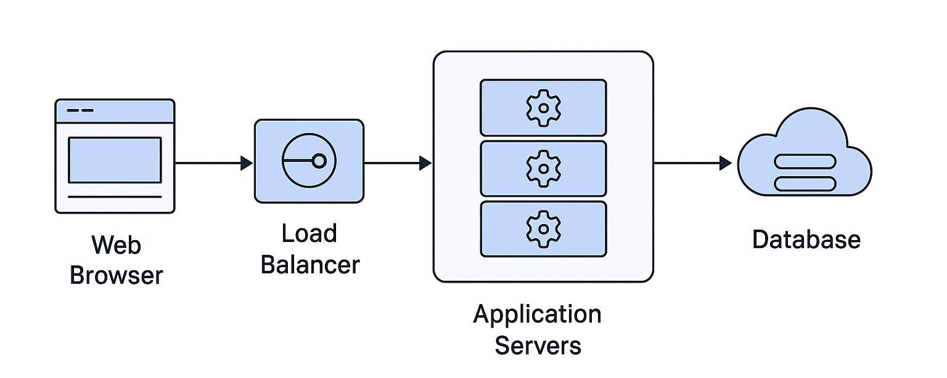
Figure 6.1 Project Development Methodology
1. Requirement Analysis:
During the phase, the non-functional and functional requirements of the UniVerse system are collected by holding meetings with the stakeholders, such as students, leaders of the society and administrators. Extensive documentation is carried out to establish clear project objectives, scope as well as user expectations.
2. System Design:
System architecture, database schema and user interface designs are produced based on the requirements obtained. This consists of the development of UML diagrams, wireframes and the overall structure of the system so that, implementation is made easy in the future.
3. Implementation (Development):
The real coding operation is carried out during this stage. The frontend is created with the help of React.js, the backend with Node.js and Express.js, and the database is MongoDB. The AI module and Firebase Cloud Messaging are also integrated in order to facilitate the application of smart response and live communication.
4. Testing:
This stage entails testing of all the modules to ensure they operate properly and as per the requirements. The unit tests, integration tests and user acceptance testing (UAT) are conducted in order to detect and rectify bugs or inconsistencies so that the system is stable and reliable.
5. Deployment and Maintenance:

When the system is tested successfully, it will be deployed to a cloud service provider (Vercel or Render). The monitors and maintenance are done constantly in such a way as to deliver the maximum performance, security and user satisfaction.

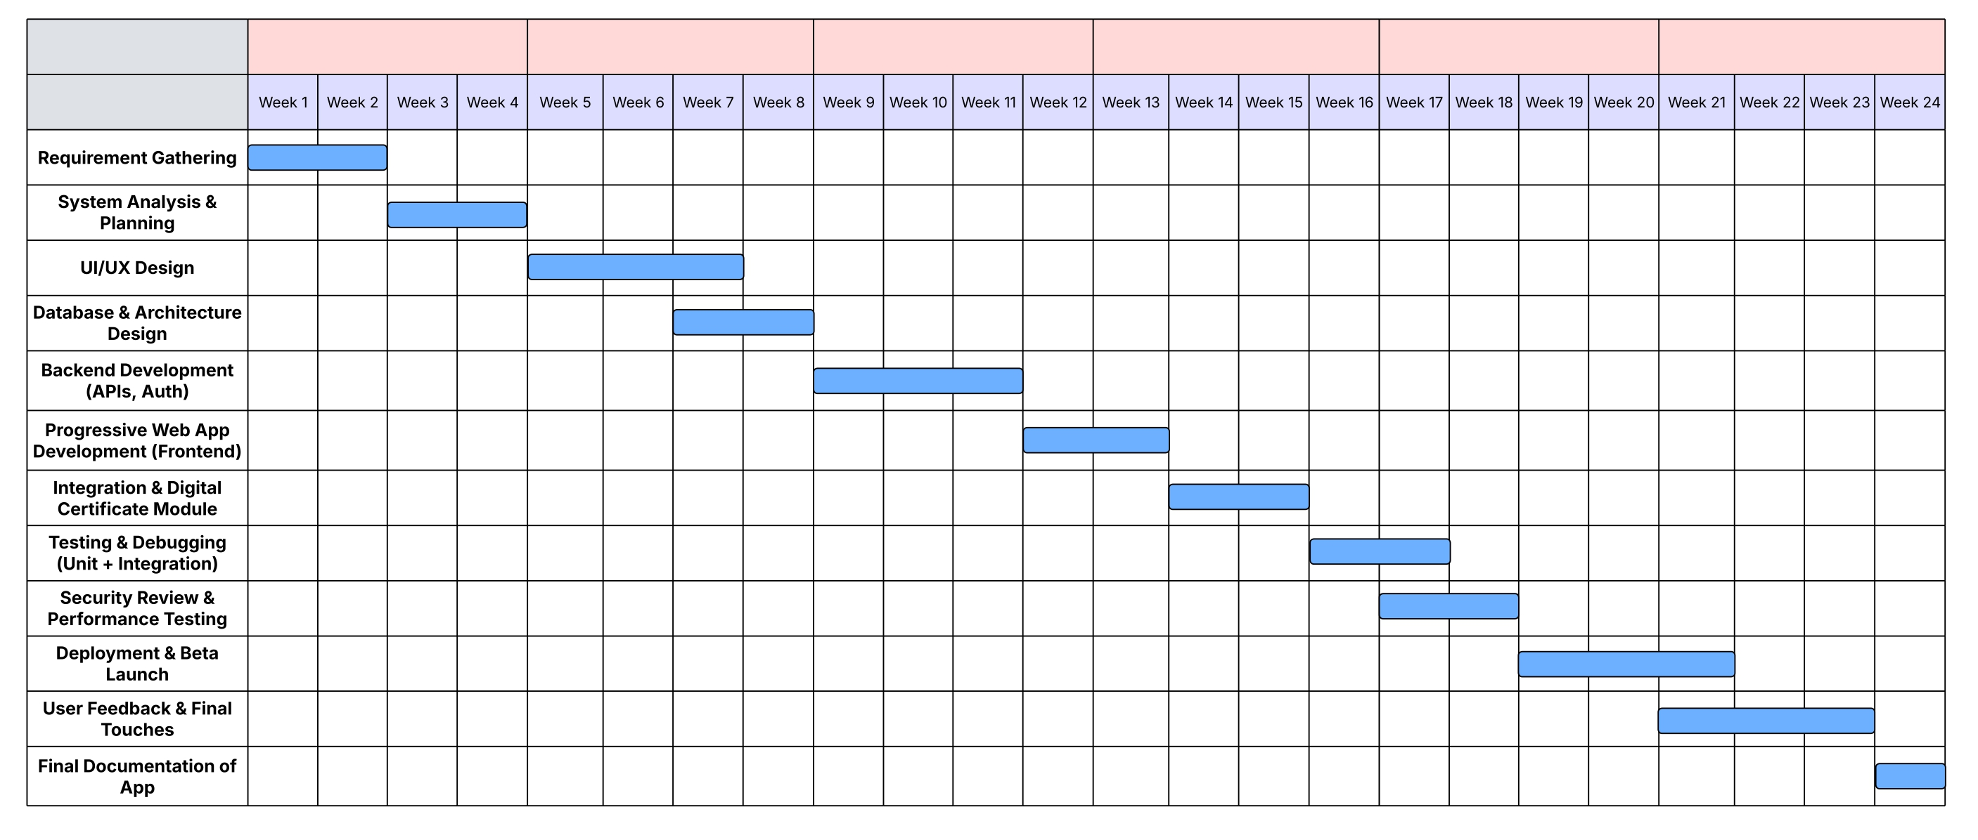
7. Project Milestones and Deliverables

8. References
Chavhan, T. et al. (2025). College Campus Club Management. IRJMETS, Vol.07, Issue 02. DOI:10.56726/IRJMETS67452
Blancaflor, E. B. (2021). A Student Organization Events Management System. ACM.
Kodidasu, S. M. et al. (2025). UnifyU – A Centralized Platform for University Club Management. IJARSCT. DOI:10.48175/IJARSCT‑24829
Duan, L. (2024). Relationship between the College Student and Club Participation. PMC.
Güneş, E. (2025). The 9 Best Student Organization Management Systems. JoinIt Blog.

